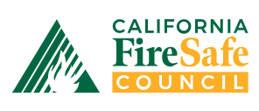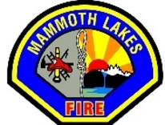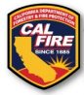

FOR IMMEDIATE RELEASE - Media Contact: Dave Easterby, Mammoth Lakes Fire Safe Council, (760) 914-0169, dave.easterby.ngk3@statefarm.com
MAMMOTH LAKES FIRE SAFE COUNCIL AND MAMMOTH LAKES FIRE DEPARTMENT TO HOST “WILDFIRE PREPAREDNESS DAY” ON MAY 7TH, 2022
AT FIRE STATION 1 ON MAIN STREET IN MAMMOTH LAKES
Promoting Awareness about Wildfire Preparedness and Prevention
Mammoth Lakes, CA (April 2022) – The Governor of the State of California has proclaimed May 1 – 7, 2022 “Wildfire Preparedness Week” as a wakeup call for residents to get prepared for this year’s fire season. The Mammoth Lakes Fire Safe Council, part of the California Fire Safe Council (CFSC), California’s leader in community resiliency and community wildfire risk reduction, is proud to join with the Mammoth Lakes Fire Department and the Regional Forest and Fire Capacity Program to provide local residents with the tools they need to prepare. The event takes place on Saturday, May 7th from 10:00am to 2:00pm at Mammoth Lakes Fire Department’s Station 1, 3150 Main Street, Mammoth Lakes, CA 93546.

Last year, California saw unprecedented fire conditions throughout the wildfire season. In 2021, a total of 2,568,948 acres burned, with 3,629 structures damaged or destroyed.** Fires uprooted residents from their homes, injuring firefighters as well as civilians. Historically, wildfires would primarily occur between May and October, but that reality has shifted, and California is impacted all year long. The long-term trend is that wildfires in the state are increasing due to climate change in California, and drought is only part of the problem. Strong winds, high heat, low humidity and lightning also create conditions for wildfires to more easily start and spread.***
“Preparedness is key for high-risk fire communities such as the Town of Mammoth Lakes,” stated Dave Easterby, Mammoth Lakes Fire Council President. “We are grateful for the extra resources to help high-risk areas better prepare for fire season and are eager to assist residents with creating defensible space around their homes as well as developing evacuation plans. As we’ve seen over the last few years, wildfire season can occur at any time during the year.”
For wildfire preparedness tips, please visit: https://www.nfpa.org/Public-Education/Fire-causes-and-risks/Wildfire/Preparing-homes-for-wildfire, and plan to stop by Station 1 on May 7th.
* * *

